Masterdata:- Technical Object Structure Build

Introduction

The purpose of building the structure is to create a comprehensive list of all technical objects that are part of site operations. Technical objects are Functional Locations (FLOC), Equipments and Sub-Equipment’s (for example tanks, pumps, agitators, motors, instruments, valves and other process equipment)

At SML we are building a structure to best represent the technical objects in process order.

The list of technical objects is important as this is used for plant maintenance to allocated BOM’s (Bills of Materials), PVM Routines (Preventative Maintenance Routines), linking drawings and documents and used by personel to create Notifications and Work Orders against the technical object.

Technical Objects

In SAP “Technical Objects” represents a physical asset or a component of a system that requires maintenance, such as a “Functional Location (FLOC)” or “Equipment/Sub-Equipment”, and is used to manage and evaluate technical assets and maintenance objects.

Where possible the “FLOC” will be used to represent equipment at the start of a process or imovable object (such as a tanks). “Equipments” will be technical objects within the system further down in the process. We are also using “Sub-Equipments” which are equipments within an equipment (example valves or instruments within a line, the line will be an equipment and the vavles or instruments will be sub-equipments)

Equipment Numbers

Equipments and Sub-Equipments will be allocated an equipment number in SAP, this is why it is really important to include the equipment identifier within the description of the technical object.

FLOC Mask

FLOC number are built using what is called a “FLOC Mask”, this describes the path within the mask of where the FLOC is within the structure. There is a maximum length limit of 30 characters for a functional location mask.

NNNN-XXXX-AA-XXX-XXXXXXXXXXXXX

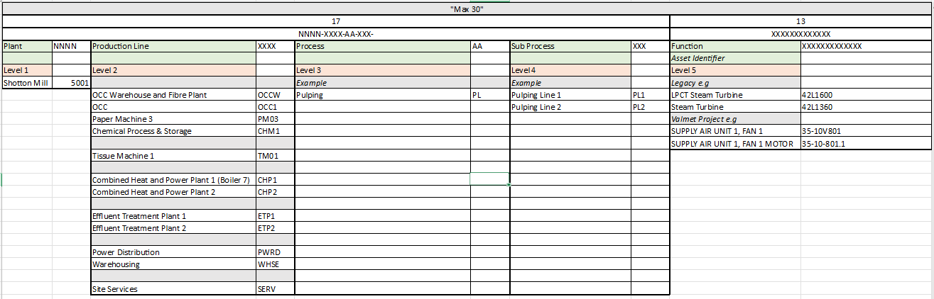

Technical Objects have what is called a “Parent” and “Child” relationship within the structure, a parent is what comes before the technical object in the structure and a child is what comes after it.

You can see here how the tree structure come together, starting at the “Plant” (5001- Shotton Mill Containerboard), moving to “Line” (CHP1- Combined Heat and Power Plant (B7)), “Process” (WS- Water Systems), “Sub-Process” (FOU- Foul Water), “Function Location” (42T6107- Effluent Tank). These will be twisty selections that you will be able to drill down to find the Technical Object you are searching for.
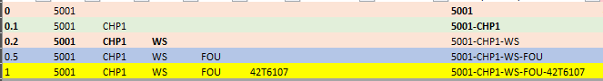

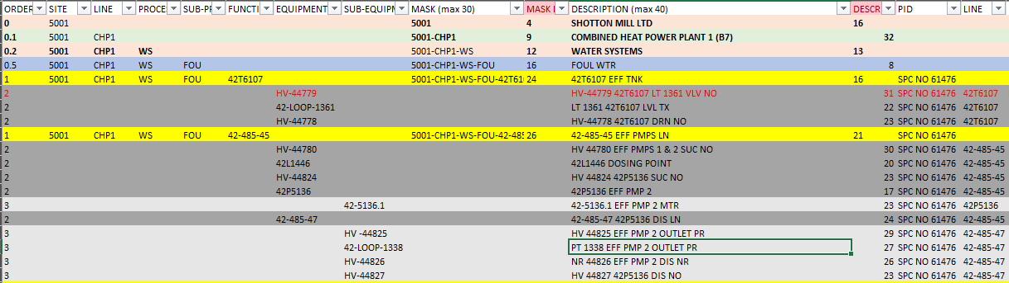

Technical Object Description

All descriptions have a maximum charcter limit of 40 characters and they are to be all in uppercase text.

Where possible for valves we would like to capture the running condition, whether it is normaly closed (NC) or normally open (NO). If the valve in the process is a process controlled valve we are not adding any further information.

They are to follow the following format as best as possible.

Asset Identifier-Description-Running Conditition(if applicable)

Examples:-

42T6103 PRE-TREATED WTR TNK
42-46627 42P5107 SUCT LN
HV 4211 42P5107 SUCT NO
HV 4212 42P5107 SUCT DRN NC
42P5107 PRE-TREATED WTR PMP 1

Abbreviations

We are creating an abbreviation standard for SML, which we are taking note of all names we are abbreviating to be used throughout all descriptions, this will make it easier searching in the future. For example the abbreviation for a “Motor” is “MTR”

The abbreviation library is stored currently in the SAP PM Teams site.

It is important that the abreviation list is followed to ensure that all abbreviations are the same, having this standard will make it easier to understand and search for “Technical Objects” when using SAP.

Structuring Technical Objects

Here I have an example of part of a PID drawing, the example shows a tank “42T6103” the Pre-Treated Water Tank, to this we have the feed line to the tank “42-46625”. These are inputed as “FLOC” type technical objects. Associated to the tank we have a number of Instuments, Lines, Valves, Pumps and Motors. You can see here how these are “Equipments” or “Sub-Equipments”

